1. 
2. In previous lecture, we discussed that a Microservice is a small app can be deployed independently.
3. The following diagram shows several microservice applications working together as a large system.  
   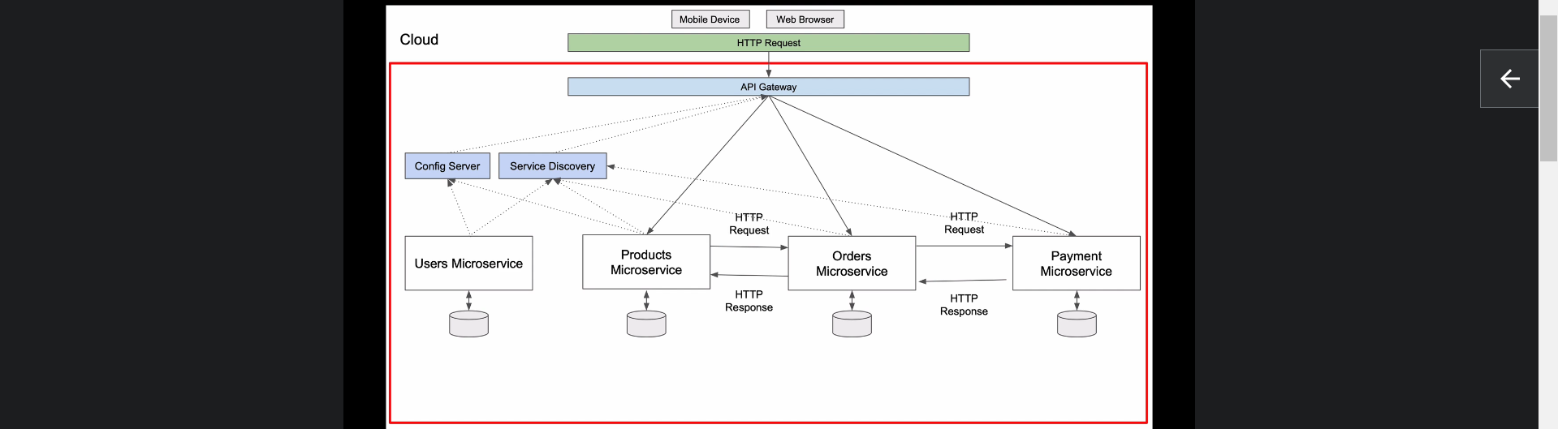
4. Each of these microservices is a small web service which runs on its unique port.
5. At the top of this diagram, we have two client applications. One is mobile app using RESTAPI and other is Web App working in Web Browser and both of them communicate with Microservices sending HTTP Request.
6. The red box represents Spring Cloud which supports environment for microservices.
7. In the Spring Cloud Environment, the very 1st microservice at the top is a **API Gateway** which is also a standalone Spring Boot Application.
8. Then we have **Config Server and Service Discovery** which are also Standalone Spring Boot Application.
9. 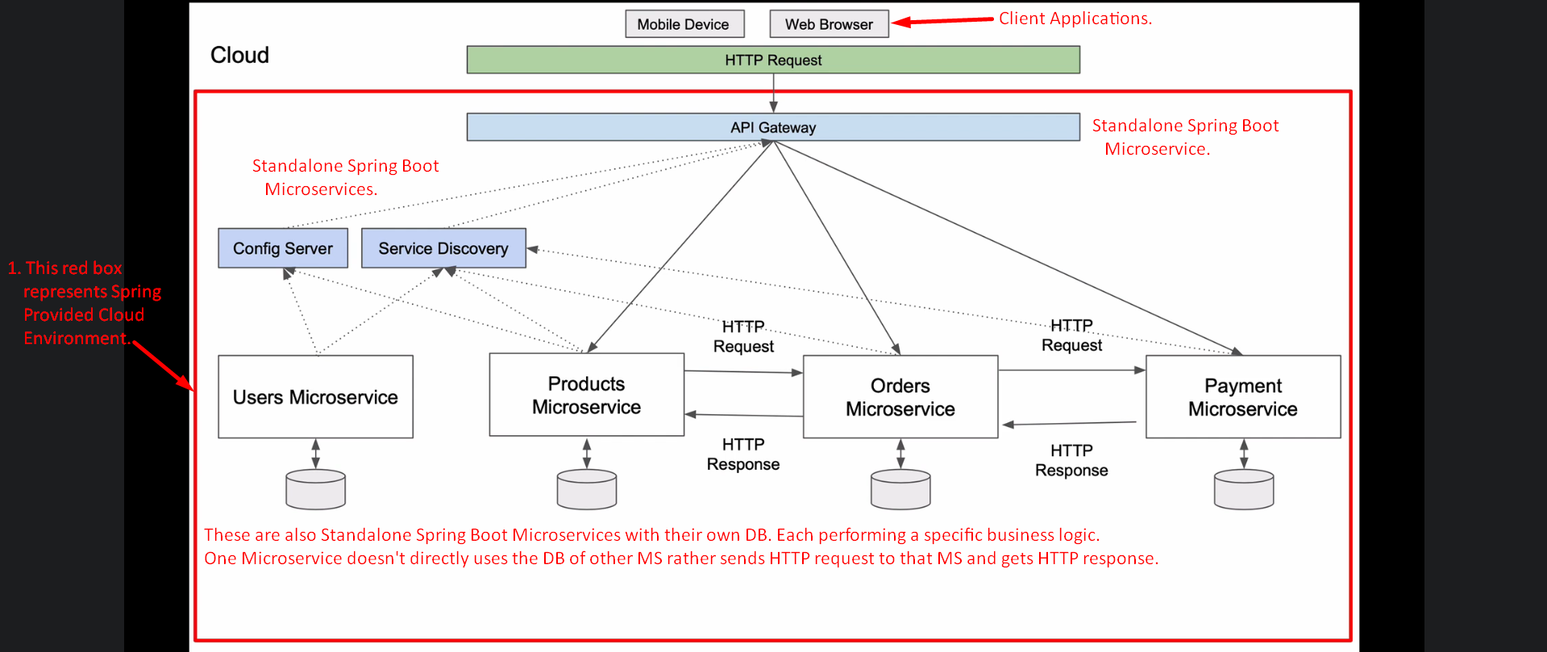
10. When it comes to direct communication, then we will come across synchronous and asynchronous HTTP Request.
11. 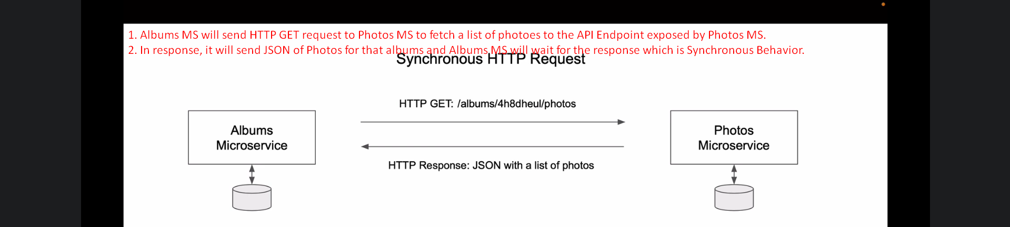
12. 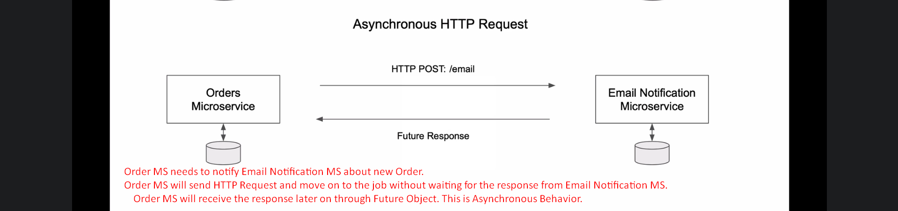
13. These are the not only two ways of communications b/w MSs.
14. 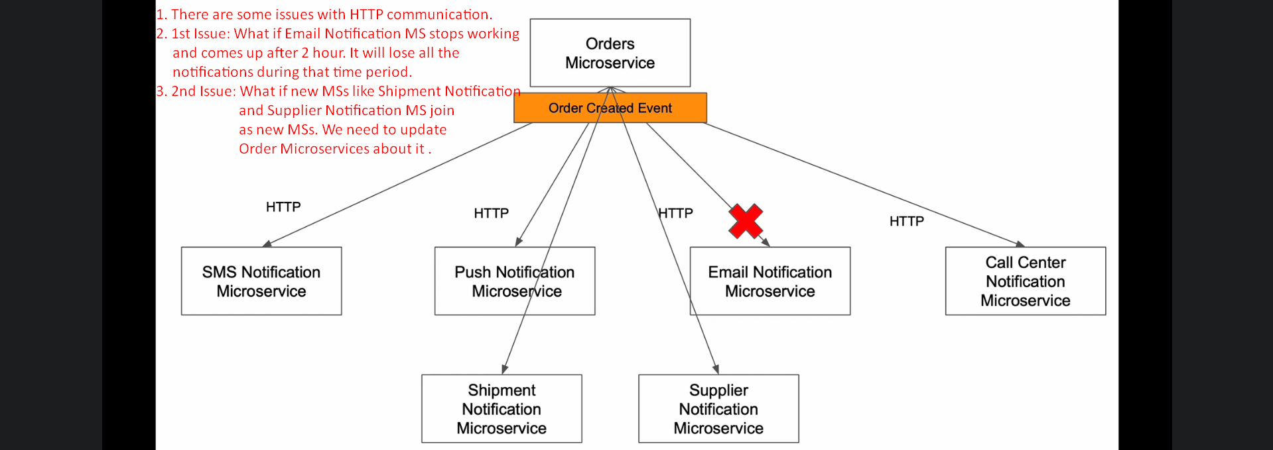
15. The HTTP communication is direct communication b/w MSs and that is reasons for these issues.
16. That is where Apache Kafka and Event Driven Communication can help.
17. Let’s see in next lecture.